Training system – business requirement document

Table of Contents

1.0 Overview 3

2.0 Scope 4

2.1 Module/Screen specification 4

3.0 Module/Screen Specification 5

3.1 Login 5

3.1.1 Normal login 5

3.1.1.1 Field validation 5

3.1.1.2 Button/Check-box validation 6

3.1.2 Email address confirmation for password setup 6

3.1.2.1 Field validation 6

3.1.2.2 Button/Check-box validation 7

3.1.3 Resetting the password 7

3.2 Candidates 8

3.2.1 Candidate overview 8

3.2.1.1 Field validation 10

3.2.1.2 Button/Check-box validation 11

3.2.2 Add candidate 11

3.2.2.1 Field validation 12

3.2.2.2 Button/Check-box validation 12

3.2.3 Bulk add candidates 13

3.2.3.1 Button/Check-box validation 13

3.3 Trainings 15

3.3.1 Trainings overview 15

3.3.1.1 Field validation 16

3.2.1.2 Button/Check-box validation 17

3.3.2 Create training 18

3.3.2.1 Field validation 18

3.3.2.2 Button/Check-box validation 21

3.3.3 Select an assessment type 22

3.3.3.1 Button/Check-box validation 22

3.3.3.1 Create assessment 23

3.3.3.1.1 Field validation 23

3.3.3.1.2 Button/Check-box validation 24

3.3.3.2 Load assessment 24

3.3.4 Attendance confirmation 25

3.3.4.1 Field validation 25

3.3.4.2 Button/Check-box validation 26

3.4 Progress 27

3.4.1 Progress module overview 27

3.4.1.1 Field validation 28

3.4.1.2 Button/Check-box validation 29

3.4.2 Manage training progress 29

3.4.2.1 Field validations 30

3.4.2.2 Button/Check-box validation 31

3.4.3 Issue assessment 32

3.4.4 Issue survey 32

3.5 Feedback 33

3.5.1 Field validation 33

3.6 Reports 34

3.7 Profiles 35

3.7.1 Field validation 36

3.7.2 Button/Check-box validation 36

3.8 Admin settings 37

# Overview

Training programs that are conducted by training department, at present, do not have a digital platform to keep track of them. Based on the requirements that have been taken into account it has been made clear of the importance of a system that can seamlessly manage the training programs. The proposed system is going to act as a portal that includes all related functionalities from the point where a candidate is being added. In addition to being a portal that is designed to perform the required functions, it will also cater to the inquiries of various users such as trainers. With this premise as an overview to the highlighted requirement, the following sections cover what the functional and non-functional requirements are.

# 2.0 Scope

## 2.1 Module/Screen specification

|  |  |  |
| --- | --- | --- |
| **No.** | **Module/Screen** | **Comments** |
| 01 | Login | The screen where a user can enter the username and password to log in to the system. |
| 02 | Candidates | The allocated module to add a candidate. (Individual and bulk uploads will be available) |
| 03 | Training | The allocated module to schedule a training program. |
| 04 | Progress | Allows a trainer to manage or get a quick view of the already created training programs. |
| 05 | Feedback | A module that is enabled for trainers and sales staff. |
| 06 | Reports | A module that can generate the reports based on the trainings. |
| 07 | Profile | The profile that is assigned to an individual who has access to the system. |
| 08 | Admin Settings | A settings panel to configure the scoped parameters of the system. |

# 3.0 Module/Screen Specification

## 3.1 Login

Business requirement - The login screen would be the entry point to the system. Using the relevant username and associated password, a user can log in to the system. At the same time, it should serve the functionality of resetting a password if a user had forgotten their password. The following wireframe diagrams represent the UIs of the particular screens.

## 3.1.1 Normal login

This screen assumes a user knows their username and password to log in to the system.

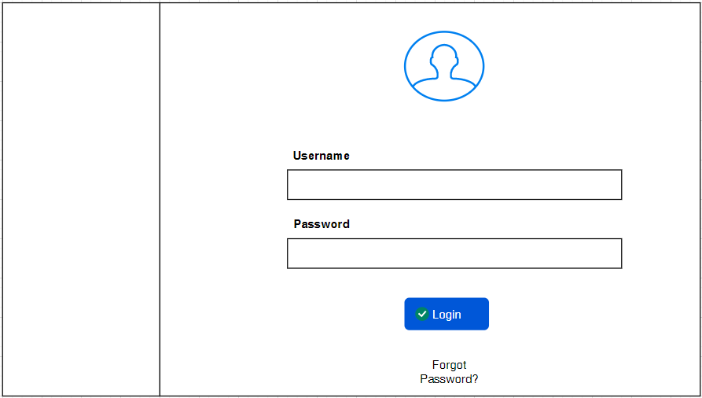

Figure - Login Screen

## 3.1.1.1 Field validation

|  |  |  |  |  |
| --- | --- | --- | --- | --- |
| **Field Name** | **Data Entry (DE)/ Auto-populate (A)/ Dropdown (D)/ Scale (S)** | **Value in case**  **Auto-populate/Dropdown** | **Mandatory** | **Business Rule** |
| Username | DE |  | Yes | Entering the username |
| Password | DE |  | Yes | Entering the password |

## 3.1.1.2 Button/Check-box validation

|  |  |  |
| --- | --- | --- |
| **Button/Checkbox/Radio Button** | **Button/Check box name** | **Action/Requirement/Validations** |
| Button | Login | Allows a user into the system |

## 3.1.2 Email address confirmation for password setup

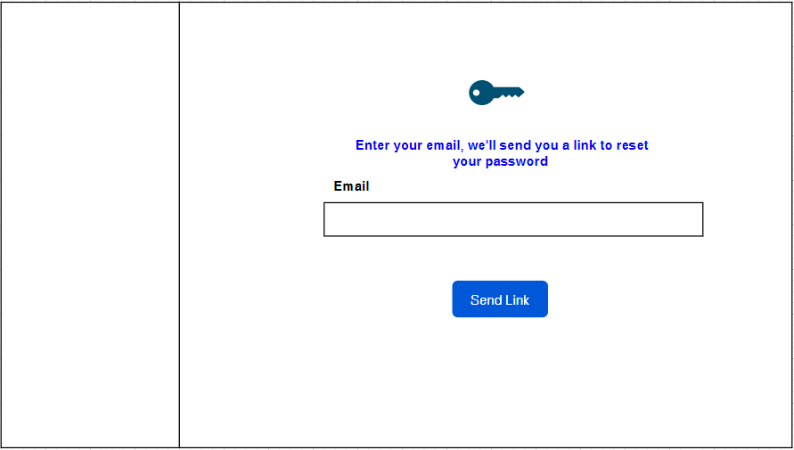

Figure - Email address confirmation

## 3.1.2.1 Field validation

|  |  |  |  |  |
| --- | --- | --- | --- | --- |
| **Field Name** | **Data Entry (DE)/ Auto-populate (A)/ Dropdown (D)/ Scale (S)** | **Value in case**  **Auto-populate/Dropdown** | **Mandatory** | **Business Rule** |
| Email | DE |  | Yes | Entering the email address to which the password reset link needs to be sent |

## 3.1.2.2 Button/Check-box validation

|  |  |  |
| --- | --- | --- |
| **Button/Checkbox/Radio Button** | **Button/Check box name** | **Action/Requirement/Validations** |
| Button | Send Link | Sends a password reset link to the email address. |

## 3.1.3 Resetting the password

Business requirement – This screen should allow a user of the system to reset their password. Two instances would be taken place here where the first is to type out the new password and second one being where the password needs to be confirmed.

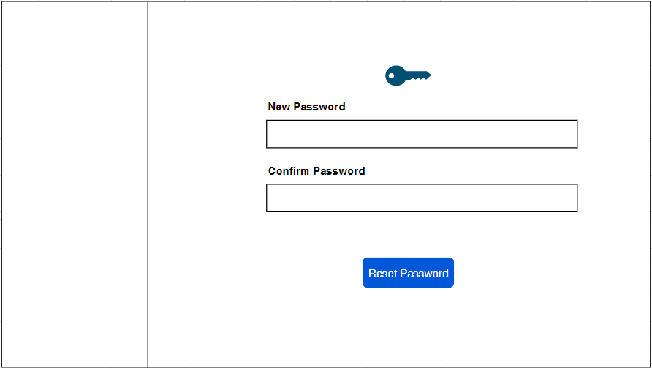

Figure - Password resetting screen

## 3.2 Candidates

Business requirement – This module should be able to add candidates to the system. Candidates can be added either as individuals or as a bulk at once. In addition to that, this module should also be able to view, edit and even delete candidates. The controls to be placed here will function accordingly. This module has to be only accessible by the admins, trainers and required sales personnel. For the sales personnel, the candidates will be filtered based on zone, region, branch and channel. For an admin the candidates will be filtered based on all zones, all regions, all branches and all channels.

## 3.2.1 Candidate overview

Business requirement – By default, the status of a candidate should be mentioned as ‘CDS1’. Upon completion of training, the status will switch from ‘CDS1’ to ‘Pending Code’. Subsequently, a notification should be sent to AVO stating that the candidate has completed the CDS1 training. An API integration with AVO has to be done here to notify AVO that the candidate’s CDS1 training has been completed. Eventually, the code will be updated in the training system and it will prompt the status change to ‘Training Path’. The candidate status needs to change from ‘Training Path’ to ‘Completed’ once all trainings (AVO, CDS2, CDS3) are completed. The names of candidates who fail to join the trainings for over 3 times will be sent to Zonal manager/training head via email. The editable data fields of a candidate are only the basic information. The candidate ID, NIC, Code, Status, Training Status, Training history, and attendance information will not be able to be altered. If the zone, region, branch or channel of a candidate is changed, the candidate needs to be moved under the corresponding zonal manager, region, branch and channel accordingly.

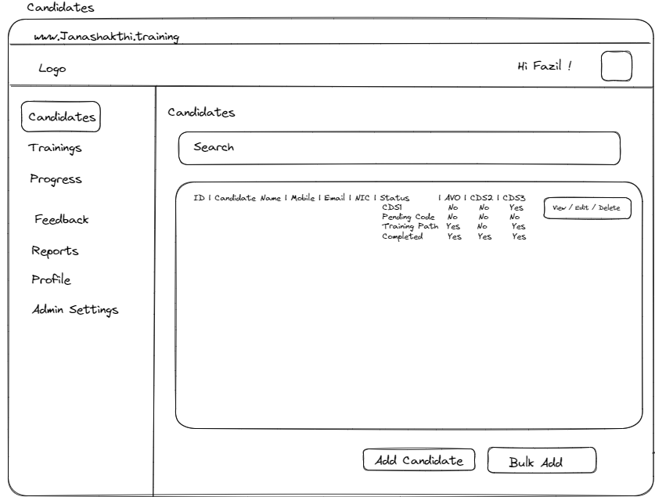

Figure - Candidates module overview

## 3.2.1.1 Field validation

|  |  |  |  |  |
| --- | --- | --- | --- | --- |
| **Field Name** | **Data Entry (DE)/ Auto-populate (A)/ Dropdown (D)/ Scale (S)** | **Value in case**  **Auto-populate/Dropdown** | **Mandatory** | **Business Rule** |
| Search | DE |  | No | A candidate can be searched for by their name, NIC or status. |
| ID | A | IDs of the added candidates | Yes | The IDs of the existing candidates should be displayed. |
| Mobile | A | The mobile numbers of the existing candidates | Yes | The mobile numbers of the existing candidates should be displayed |
| Email | A | The email addresses of the existing candidates | Yes | The email addresses of the existing candidates should be displayed. |
| NIC | A | The NIC of the existing candidates | Yes | The NIC of the existing candidates should be displayed. |
| Status | A | CDS1, Pending Code, Training Path, Completed | Yes | The current status corresponding to the types of training programs completed should be displayed. |
| AVO | A | Yes, No | Yes | It should be displayed whether this training has been completed or not. |
| CDS2 | A | Yes, No | Yes | It should be displayed whether this training has been completed or not. |
| CDS3 | A | Yes, No | Yes | It should be displayed whether this training has been completed or not. |

## 3.2.1.2 Button/Check-box validation

|  |  |  |
| --- | --- | --- |
| **Button/Checkbox/Radio Button** | **Button/Check box name** | **Action/Requirement/Validations** |
| Button | View | A candidate should be able to be viewed. |
| Button | Edit | A candidate’s data should be able to be edited. |
| Button | Delete | A candidate should be able to be deleted. |
| Button | Add Candidate | A candidate should be able to be added |
| Button | Bulk upload | A set of candidates should be able to be added at once using a excel file that contains the list of candidates. |

## 3.2.2 Add candidate

Business requirement – The screen should place the required data fields to capture the data of a candidate.

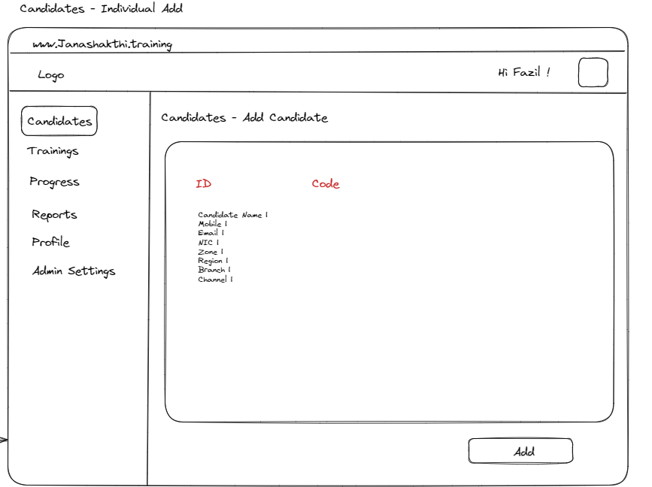

Figure - Add candidate screen

## 3.2.2.1 Field validation

|  |  |  |  |  |
| --- | --- | --- | --- | --- |
| **Field Name** | **Data Entry (DE)/ Auto-populate (A)/ Dropdown (D)/ Scale (S)** | **Value in case**  **Auto-populate/Dropdown** | **Mandatory** | **Business Rule** |
| Candidate ID | A | The system should assign an ID for the candidate | Yes | Allocates an ID for the candidate |
| Candidate Code | A | The code that has been generated | Yes | Displays the code of the candidate |
| Candidate name | DE |  | Yes | Entering the name of a candidate |
| Mobile | DE |  | Yes | Entering the mobile number of a candidate. |
| Email | DE |  | Yes | Entering the email address of a candidate. |
| NIC | DE |  | Yes | Entering the NIC of a candidate. |
| Zone | DE |  | Yes | Entering the zone to which a candidate belongs. |
| Region | DE |  | Yes | Entering the region to which a candidate belongs. |
| Branch | DE |  | Yes | Entering the branch of a candidate. |
| Channel | DE |  | Yes | Entering the channel of a candidate. |

## 3.2.2.2 Button/Check-box validation

|  |  |  |
| --- | --- | --- |
| **Button/Checkbox/Radio Button** | **Button/Check box name** | **Action/Requirement/Validations** |
| Button | Add | Adds a candidate to the system. |

## 3.2.3 Bulk add candidates

Business requirement – This screen should be able to add a selected crop of candidates all at once using a CSV file. The corresponding data fields that identify a candidate should be placed in the form of columns in the CSV file. Duplicate entries need to be omitted. Based on NIC a candidate can uniquely be identified and thus an NIC validation needs to be implemented. When adding a bulk of candidates, it is possible to add them with after changing the status. This means that there could multiple candidates with different statuses unlike in an individual addition of a candidate.

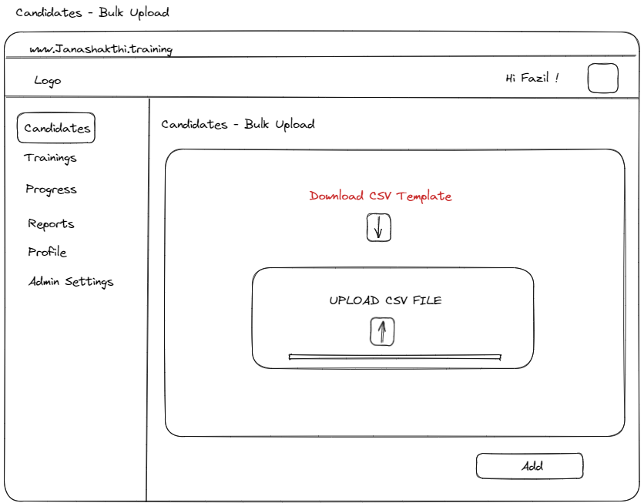

Figure - Bulk upload screen

## 3.2.3.1 Button/Check-box validation

|  |  |  |
| --- | --- | --- |
| **Button/Checkbox/Radio Button** | **Button/Check box name** | **Action/Requirement/Validations** |
| Button | Download CSV template | Downloads the CSV template into which the candidates should be added. |
| Button | Upload CSV file | Uploads the CSV file where the candidates have been added. |
| Button | Add | Successfully adds the candidates in the CSV file to the system. |

## 3.3 Trainings

Business requirement – This module should be able to schedule trainings as well as manage the scheduled trainings such as to edit and delete trainings. Trainers should be given the system privileges to view, edit or delete trainings where are the FSA will only be able to view the trainings scheduled for their respective forms and view the candidate participation status. The required assessment forms have to be prepared and assigned before scheduling a training.

## 3.3.1 Trainings overview

Business requirement – Display the scheduled trainings.

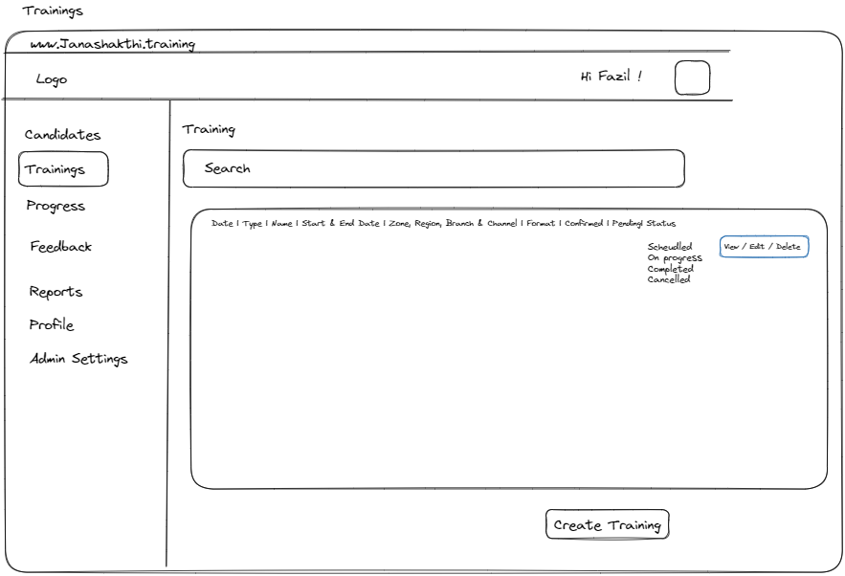

Figure - Overview of trainings

## 3.3.1.1 Field validation

|  |  |  |  |  |
| --- | --- | --- | --- | --- |
| **Field Name** | **Data Entry (DE)/ Auto-populate (A)/ Dropdown (D)/ Scale (S)** | **Value in case**  **Auto-populate/Dropdown** | **Mandatory** | **Business Rule** |
| Search | DE |  |  | A search field for the users to search for the scheduled training programs. |
| Date | A | The system picked date | Yes | The date on which the training has been created. |
| Type | A | CDS1, AVO, CDS2, CDS3 | Yes | The type of the training program has to be displayed. |
| Name | A | The name of the training program | Yes | The name of the training program needs to be displayed. |
| Start date | A | The relevant start date | Yes | The date at which the training needs to start should be displayed. |
| End date | A | The relevant end date | Yes | The date at which the training ends needs to be displayed. |
| Zone | A | The relevant zones | Yes | The zone for which the training is arranged has to be displayed. |
| Region | A | The relevant regions | Yes | The region for which the training is arranged has to be displayed. |
| Branch | A | The relevant branch | Yes | The branch for which the training is arranged has to be displayed. |
| Channel | A | The relevant channel | Yes | The channel for which the training is arranged has to be displayed. |
| Format | A | Online, Physical | Yes | The medium through which the training program will be commenced has to be displayed. |
| Confirmed | A | Yes, No | Yes | Whether the training program has been confirmed to be commenced needs to be displayed. |
| Status | A | Scheduled, in progress, completed, cancelled | Yes | The status of the training program has to be displayed. |

## 3.2.1.2 Button/Check-box validation

|  |  |  |
| --- | --- | --- |
| **Button/Checkbox/Radio Button** | **Button/Check box name** | **Action/Requirement/Validations** |
| Button | View | A user should be able to view a training based on the allocated system privileges. |
| Button | Edit | A trainer should be able to edit a training program. |
| Button | Delete | A trainer should be able to delete a training program. |
| Button | Create training | A trainer should be able to create a training program. |

## 3.3.2 Create training

Business requirement – This screen should be able to create a new training program based on the preferences of the trainer.

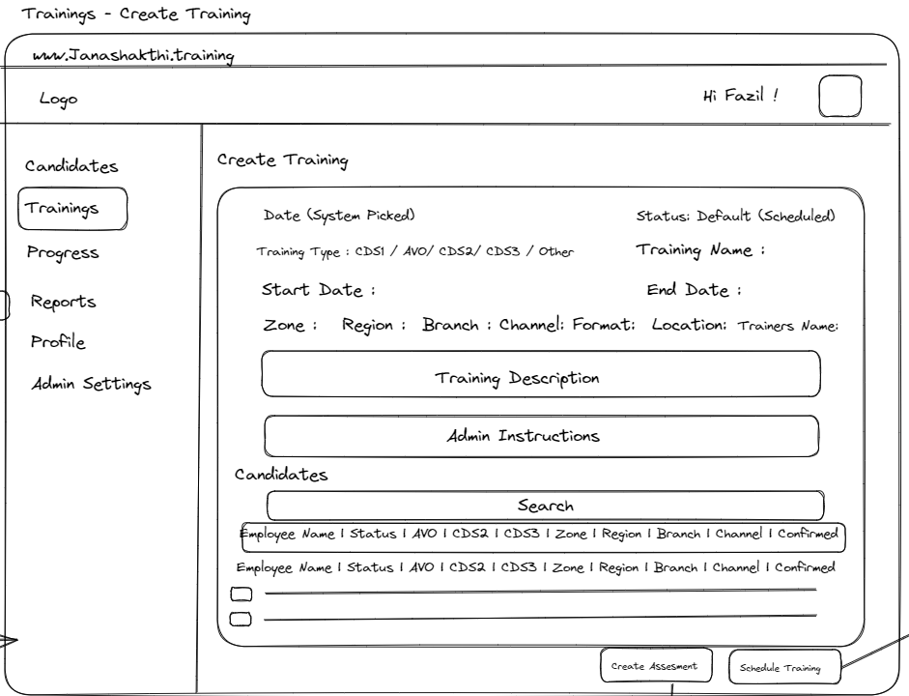

Figure - Create training screen

## 3.3.2.1 Field validation

|  |  |  |  |  |
| --- | --- | --- | --- | --- |
| **Field Name** | **Data Entry (DE)/ Auto-populate (A)/ Dropdown (D)/ Scale (S)** | **Value in case**  **Auto-populate/Dropdown** | **Mandatory** | **Business Rule** |
| Date | A | The system needs to pick the time | Yes | Picking up the time at which the meeting is created. |
| Status | A | By default - Schedule | Yes | Displaying the status of the training. |
| Training type | D | CDS1, AVO, CDS2, CDS3, Other | Yes | Selecting the type of the training |
| Training name | DE |  | Yes | Entering the name of the training |
| Start Date | DE |  | Yes | Choosing the start date |
| End Date | DE |  | Yes | Choosing the end date |
| Zone | D | The relevant zones | Yes | Choosing a zone for which a training is arranged |
| Region | D | The relevant regions | Yes | Choosing a region for which a training is arranged |
| Branch | D | The relevant branches | Yes | Choosing a branch for which a training is arranged |
| Channel | D | The relevant channels | Yes | Choosing a channel for which a training is arranged |
| Format | D | Online, Physical | Yes | Choosing the format in which the training will be held |
| Location | DE |  | Yes | Choosing the location where the training will be held |
| Trainer’s name | D | The names of the trainers | Yes | Selecting a trainer for the training |
| Training description | DE |  | Yes | Adding a description for the training |
| Admin instructions | DE |  | Yes | Adding the instructions for the admin |
| Search | DE |  | Yes | Using this search option a trainer can search for the candidates and add for the training. The view of the candidates has been specified below. |

For the ease of the trainer, the candidates should be sorted by a set of criteria. The candidates should be sorted by,

* Employee name – To be sorted alphabetically
* Status – To be sorted by status
* AVO – To be sorted by the candidates who have completed the AVO training
* CDS2 - To be sorted by the candidates who have completed the CDS2 training
* CDS3 - To be sorted by the candidates who have completed the CDS3 training
* Zone – To be sorted by the zone
* Region – To be sorted by the region
* Branch – To be sorted by the branch
* Channel – To be sorted by the channel
* Confirmed – To be sorted by the candidates who have confirmed their attendance and those who have not.

Once the candidates are being added, they will be displayed through a view as follows.

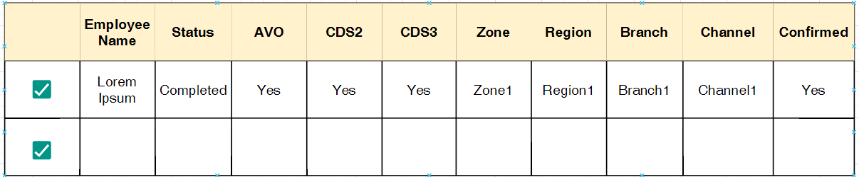

Figure - Candidate view of the training module

The columns of the above table represent the data that is used to identify a candidate uniquely. In front of each column a check-box has to be placed so that a trainer can either select or omit a candidate.

## 3.3.2.2 Button/Check-box validation

|  |  |  |
| --- | --- | --- |
| **Button/Checkbox/Radio Button** | **Button/Check box name** | **Action/Requirement/Validations** |
| Button | Create assessment | Allows the trainer to create an assessment for the candidates following a training program |
| Button | Schedule training | Allows a trainer to schedule the training |

Additional notes – Once a training is scheduled, all candidates should receive an Email and an SMS notification along with a URL to confirm participation. Amendments such as change of start and end date, location, addition/removal of a participant, status change, format change or any other related edits should prompt notifications to the users too. Upon any of the mentioned amendments, the trainer should add a remark reasoning why the amendment has been made. After every edit, an audit trial needs to be reflected with each edit that has been made along with the associated user names, timestamps and remarks. A training should be created 1 week prior to the arranged date and the notifications have to be sent via email and SMS to candidates 3 days prior to the training.

## 3.3.3 Select an assessment type

Business requirement – A trainer should be able to either create a new assessment or load one from the database.

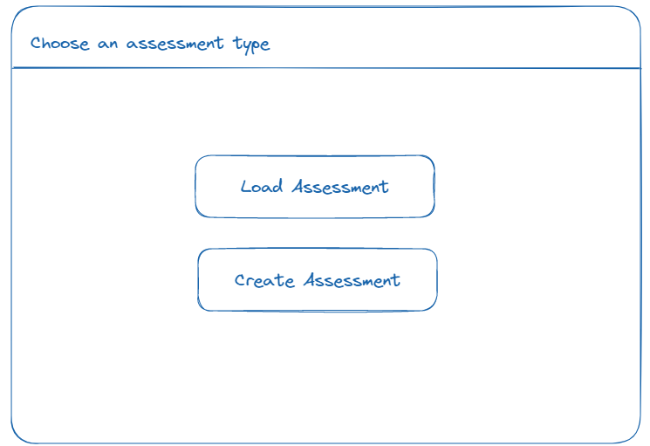

Figure – Choosing an assessment type

## 3.3.3.1 Button/Check-box validation

|  |  |  |
| --- | --- | --- |
| **Button/Checkbox/Radio Button** | **Button/Check box name** | **Action/Requirement/Validations** |
| Button | Load assessment | Allows the trainer to create an assessment for the candidates following a training program |
| Button | Create assessment | Allows a trainer to schedule the training |

## 3.3.3.1 Create assessment

Business requirement – A trainer should be able to create a new assessment

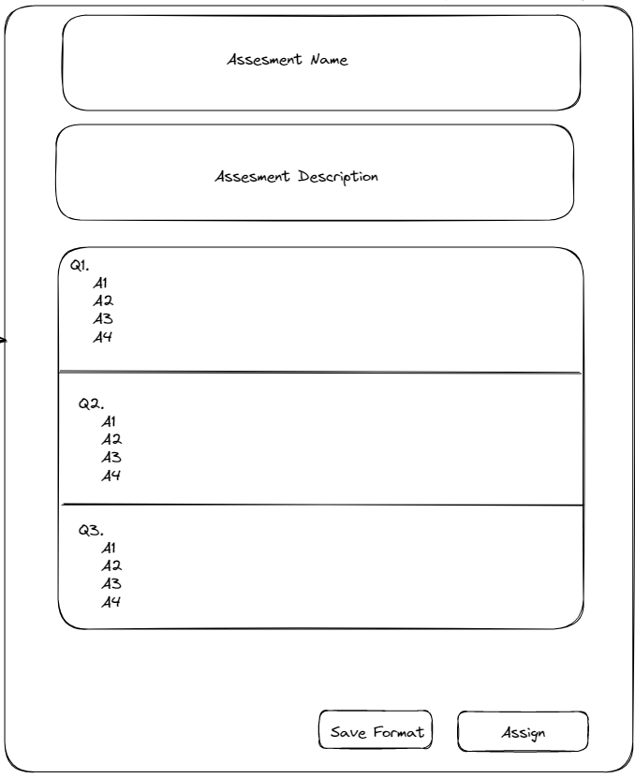

Figure - Create assessment

## 3.3.3.1.1 Field validation

|  |  |  |  |  |
| --- | --- | --- | --- | --- |
| **Field Name** | **Data Entry (DE)/ Auto-populate (A)/ Dropdown (D)/ Scale (S)** | **Value in case**  **Auto-populate/Dropdown** | **Mandatory** | **Business Rule** |
| Assessment name | DE |  | Yes | Entering a name for the assessment |
| Assessment description | DE |  | Yes | Entering a description for the assessment |

After filling out these two data fields a trainer can add the questions that are required.

## 3.3.3.1.2 Button/Check-box validation

|  |  |  |
| --- | --- | --- |
| **Button/Checkbox/Radio Button** | **Button/Check box name** | **Action/Requirement/Validations** |
| Button | Save format | Upon saving the format, the assessment would be saved to the database. The load option should be able to load an assessment of which the format is saved to the database. |
| Button | Assign | Upon assigning, a trainer can assign the assessment to a created training program. |

## 3.3.3.2 Load assessment

Upon clicking on this, a trainer should be able to load an assessment from the database.

## 3.3.4 Attendance confirmation

Business requirement – This screen should display the training details to the candidate where they can either accept or reject the invitation. If they reject the invitation, a reason needs to be provided.

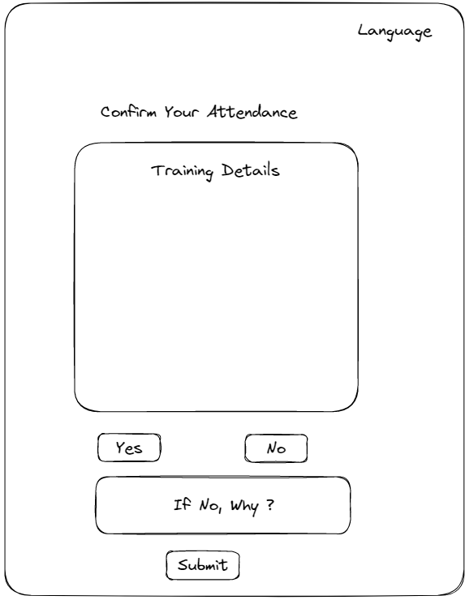

Figure - Training program invitation

## 3.3.4.1 Field validation

|  |  |  |  |  |
| --- | --- | --- | --- | --- |
| **Field Name** | **Data Entry (DE)/ Auto-populate (A)/ Dropdown (D)/ Scale (S)** | **Value in case**  **Auto-populate/Dropdown** | **Mandatory** | **Business Rule** |
| If no why? | DE |  | Yes | A candidate should provide a reason for their absence. |

## 3.3.4.2 Button/Check-box validation

|  |  |  |
| --- | --- | --- |
| **Button/Checkbox/Radio Button** | **Button/Check box name** | **Action/Requirement/Validations** |
| Button | Yes | A candidate can confirm that they will attend the training. |
| Button | No | A candidate can reject the invitation. As soon as this button is clicked, a textbox should appear where the candidate needs to mention the reason for absence. |
| Button | Submit | Upon clicking on submit, the response will be reflected in all places that display the confirmation of a candidate. |

Additional notes – The participation responses should be closed 48 hours prior to the time of the scheduled training and an email needs to be sent to admin.

## 3.4 Progress

Business requirement – The progress module will only be accessible by the trainers. This module will have the list of scheduled training programs where a trainer can search and view the training information. The attendance of the participants can be marked and also the remarks can be added by the trainer.

## 3.4.1 Progress module overview

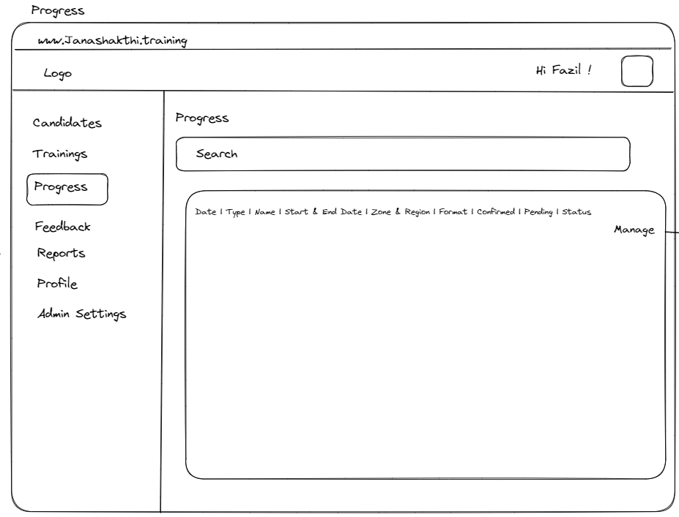

Figure - Progress module overview

## 3.4.1.1 Field validation

|  |  |  |  |  |
| --- | --- | --- | --- | --- |
| **Field Name** | **Data Entry (DE)/ Auto-populate (A)/ Dropdown (D)/ Scale (S)** | **Value in case**  **Auto-populate/Dropdown** | **Mandatory** | **Business Rule** |
| Search | DE |  |  | A search field for the trainer to search for the scheduled training programs. |
| Date | A | The system picked date | Yes | The date on which the training has been created. |
| Type | A | CDS1, AVO, CDS2, CDS3 | Yes | The type of the training program has to be displayed. |
| Name | A | The name of the training program | Yes | The name of the training program needs to be displayed. |
| Start date | A | The relevant start date | Yes | The date at which the training needs to start should be displayed. |
| End date | A | The relevant end date | Yes | The date at which the training ends needs to be displayed. |
| Zone | A | The relevant zones | Yes | The zone for which the training is arranged has to be displayed. |
| Region | A | The relevant regions | Yes | The region for which the training is arranged has to be displayed. |
| Format | A | Online, Physical | Yes | The medium through which the training program will be commenced has to be displayed. |
| Confirmed | A | Yes, No | Yes | Whether the training program has been confirmed to be commenced needs to be displayed. |
| Status | A | Scheduled, in progress, completed, cancelled | Yes | The status of the training program has to be displayed. |

## 3.4.1.2 Button/Check-box validation

|  |  |  |
| --- | --- | --- |
| **Button/Checkbox/Radio Button** | **Button/Check box name** | **Action/Requirement/Validations** |
| Button | Manage | Allows the trainer manage the training progress. Section 3.4.2 highlights the screen to which the trainer is navigated upon clicking on manage. |

## 3.4.2 Manage training progress

Business requirement – The trainer should be able to view the information of a completed training program.

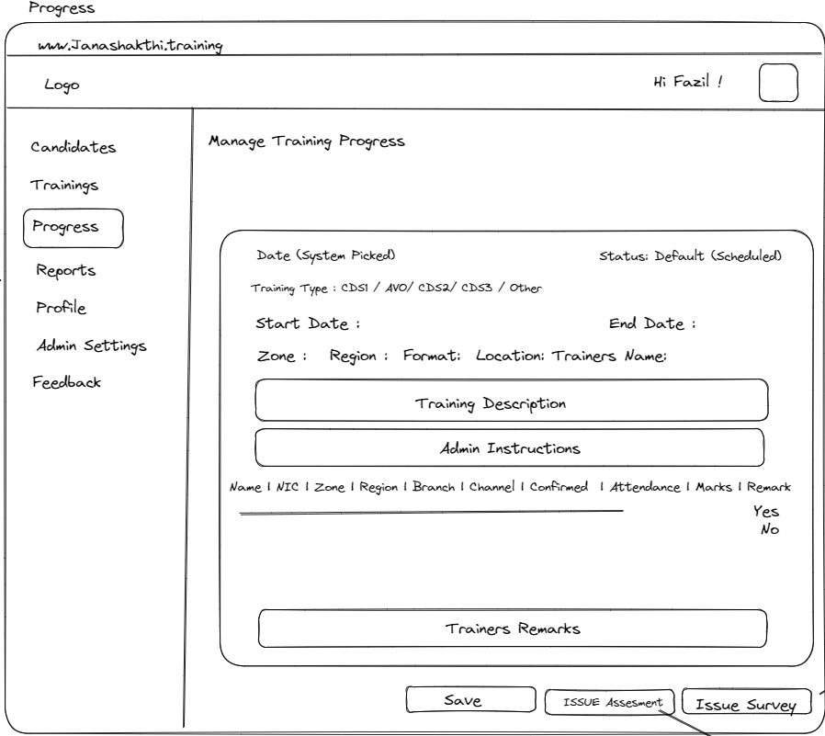

Figure - Manage training progress

## 3.4.2.1 Field validations

|  |  |  |  |  |
| --- | --- | --- | --- | --- |
| **Field Name** | **Data Entry (DE)/ Auto-populate (A)/ Dropdown (D)/ Scale (S)** | **Value in case**  **Auto-populate/Dropdown** | **Mandatory** | **Business Rule** |
| Date | A | The system needs to pick the time | Yes | Picking up the time at which the meeting is created. |
| Status | A | By default - Schedule | Yes | Displaying the status of the training. |
| Training type | A | CDS1, AVO, CDS2, CDS3, Other | Yes | Displaying the type of the training |
| Training name | A | The given name for the training | Yes | Displaying the name of the training |
| Start Date | A | The given start date | Yes | Displaying the start date |
| End Date | A | The given end date | Yes | Displaying the end date |
| Zone | A | The chosen zone | Yes | Displaying the zone for which a training is arranged |
| Region | A | The chosen region | Yes | Displaying the region for which a training is arranged |
| Branch | A | The chosen branch | Yes | Displaying the branch for which a training is arranged |
| Channel | A | The chosen channel | Yes | Displaying the channel for which a training is arranged |
| Format | A | Online, Physical | Yes | Displaying the format in which the training will be held |
| Location | A | The chosen location | Yes | Displaying the location where the training will be held |
| Trainer’s name | A | The chosen trainer | Yes | Displaying the trainer for the training |
| Training description | A | The given description | Yes | Displaying the description for the training |
| Admin instructions | A | The given instructions | Yes | Displaying the instructions for the admin |
| Trainer’s remarks | DE |  | Yes | A trainer can add the remarks regarding the training. |

Below this view a list of the participants along with the following details will be shown in a tabular format.

* Name – Name of the participant
* NIC – NIC of the participant
* Zone – Zone to which a participant belongs
* Region – Region to which a participant belongs
* Branch – Branch to which a participant belongs
* Channel – Channel to which a participant belongs
* Confirmed – Whether the participant confirmed participation
* Attendance – Present or not
* Marks – Marks for the assessment
* Remark –

## 3.4.2.2 Button/Check-box validation

|  |  |  |
| --- | --- | --- |
| **Button/Checkbox/Radio Button** | **Button/Check box name** | **Action/Requirement/Validations** |
| Button | Save | The training progress should be saved as a draft. |
| Button | Issue assessment | The prepared assessment can be issued for the training program. |
| Button | Issue Survey | A survey can be issued regarding the trainer or the training. |

## 3.4.3 Issue assessment

Business requirement – The allocated assessment can be issued using this button. The trainer should be able to send an assessment to all the participants. The assessment URL will expire in 2 hours. Section 3.3.3.1 highlights the ways in which an assessment can be created and assigned to a training program. Once it is being assigned it will get embedded in the created training program. It will be issued once a trainer clicks on ‘Issue Assessment’.

## 3.4.4 Issue survey

Business requirement – A survey can be assigned to the participants asking about the training content and the trainer.

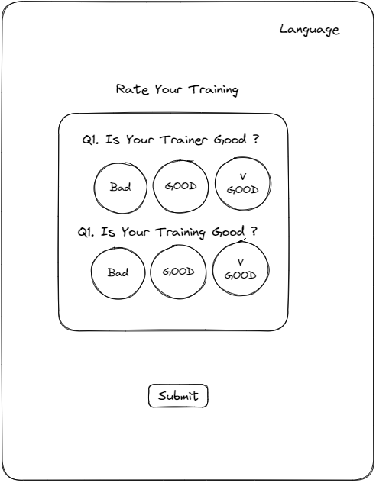

Figure - Rating screen

## 3.5 Feedback

Business requirement – The module should be accessible by the trainers and sales staff to view the feedback.

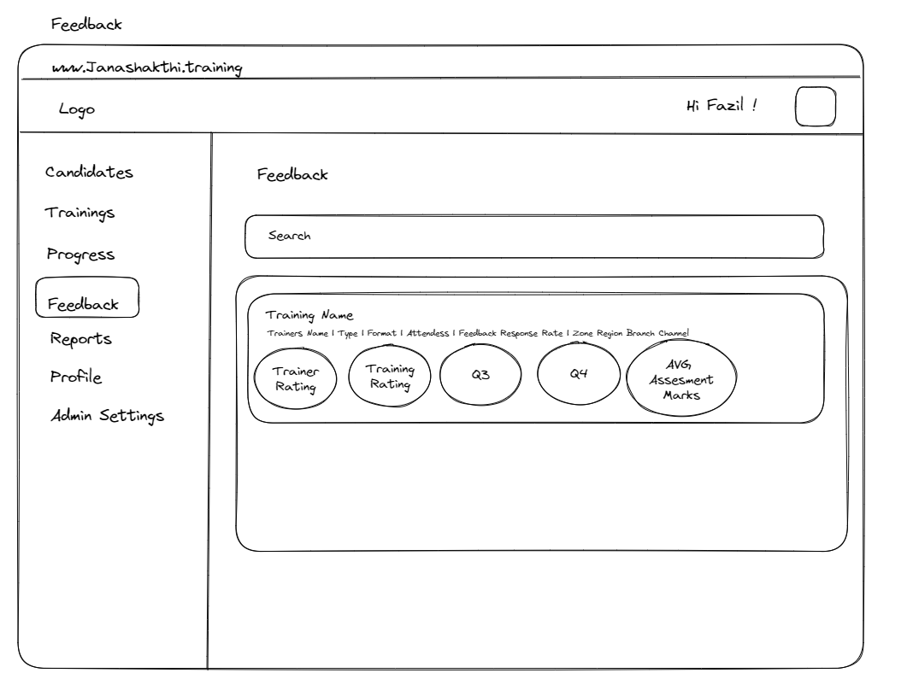

Figure - Feedback overview

## 3.5.1 Field validation

|  |  |  |  |  |
| --- | --- | --- | --- | --- |
| **Field Name** | **Data Entry (DE)/ Auto-populate (A)/ Dropdown (D)/ Scale (S)** | **Value in case**  **Auto-populate/Dropdown** | **Mandatory** | **Business Rule** |
| Search | DE |  |  | Using the search criteria the trainings can be filtered based on zone, trainer’s name etc. |

Additional notes – Upon searching for a training program, the same data fields that were used in the training module should be displayed in a tabular form. Along with that the following needs to be displayed pertaining to each training

* Trainer rating
* Training rating
* Sample question 3
* Sample question 4
* Average assessment mark

## 3.6 Reports

Business requirement – This is a module where the users of interest can download reports based on the defined criteria.

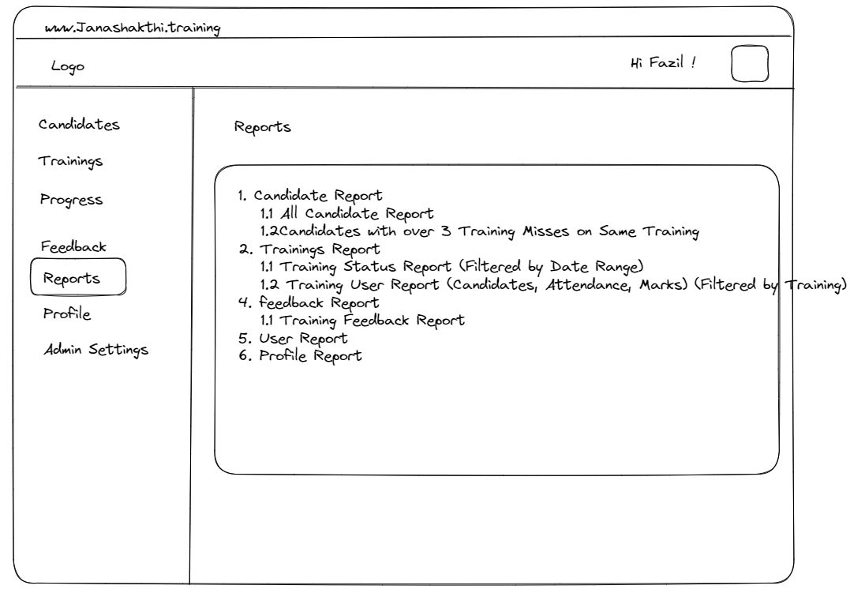

Figure - Reporting requirements

The reports to be generated should be as follows.

1. Candidate report
   1. All candidate report
   2. Candidates who have missed the same training thrice
2. Training reports
   1. Training status report (Filtered by date range)
   2. Training user report (Candidates, attendance, marks) – Filtered by training
3. Feedback report
   1. Training feedback report
4. User report
5. Profile report

## 3.7 Profiles

Business requirement – Maintain a profile for the particular user who has access to the system.

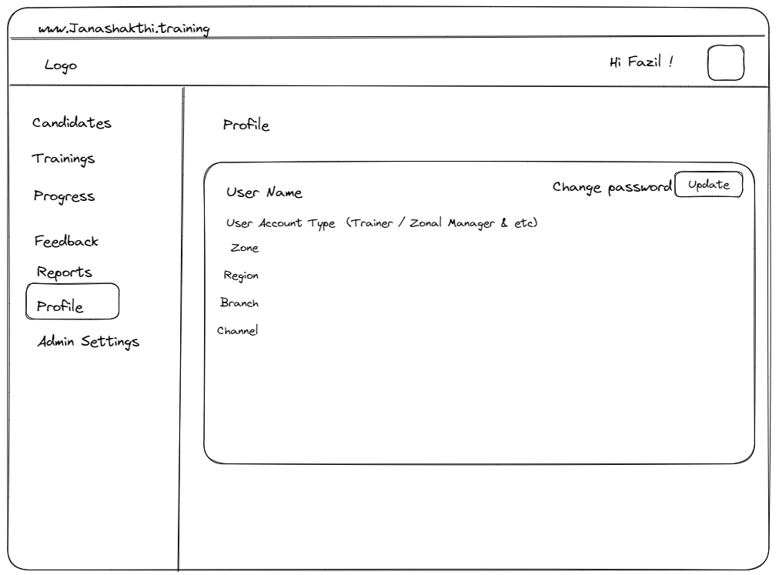

Figure -Profile overview

## 3.7.1 Field validation

|  |  |  |  |  |
| --- | --- | --- | --- | --- |
| **Field Name** | **Data Entry (DE)/ Auto-populate (A)/ Dropdown (D)/ Scale (S)** | **Value in case**  **Auto-populate/Dropdown** | **Mandatory** | **Business Rule** |
| User name | A | The created name for the system | Yes | The name of the user should be displayed |
| User account type | A | The role that has been assigned for the system | Yes | The role of user has to be displayed |
| Zone | A | The chosen zone of the user | Yes | The respective zone of the user has to be displayed |
| Region | A | The chosen region | Yes | The respective region of the user has to be displayed |
| Branch | A | The chosen branch | Yes | The respective branch of the user has to be displayed |
| Channel | A | The chosen channel | Yes | The respective channel to which the user belongs should be displayed |

## 3.7.2 Button/Check-box validation

|  |  |  |
| --- | --- | --- |
| **Button/Checkbox/Radio Button** | **Button/Check box name** | **Action/Requirement/Validations** |
| Button | Change password | A user should be taken to a portal where the password can be changed. |
| Button | Update | A user should be navigated to a screen where the user data can be edited. |

## 3.8 Admin settings

Business requirement – The purpose of this role is to define the roles and privileges of an admin.

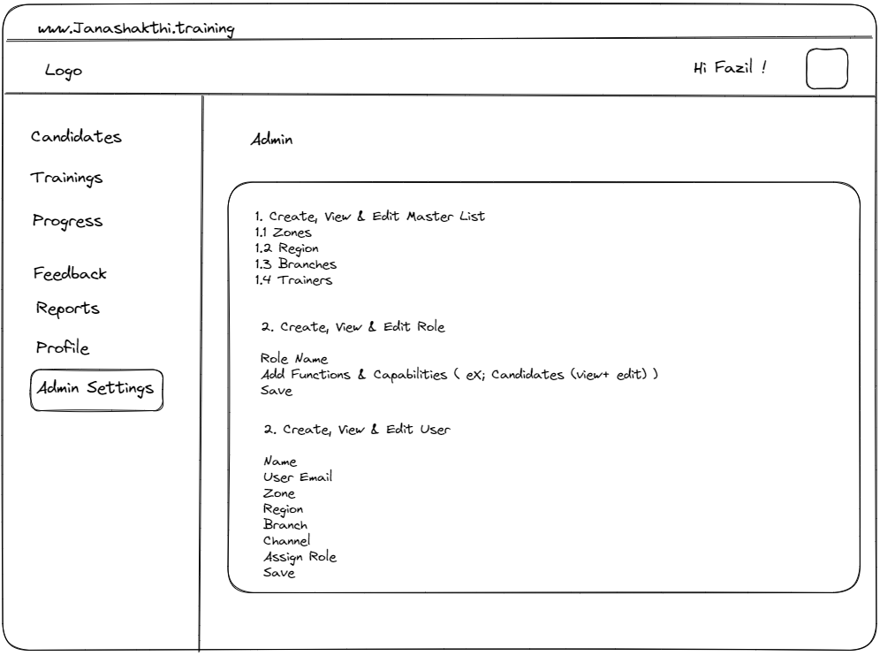

Figure - Admin settings

The main purpose of this module is to define what an admin is capable of doing and to which extent an admin can customize the system. In doing so, the following functions can be performed by an admin.

1. Create, view and edit
   1. Zones
   2. Regions
   3. Branches
   4. Trainers
2. Create, View and edit roles
   1. Role name
   2. Add functions and capabilities to each role
   3. Save those changes
3. Create view and edit,
   1. Names of users
   2. User emails
   3. Zone of a user
   4. Region of a user
   5. Branch of a user
   6. Channel of a user
   7. Assigning a preferred role
   8. Save changes